Parallel execution with the help of gitactions –

1. Login to Github and navigate to the repository
2. Click on Actions

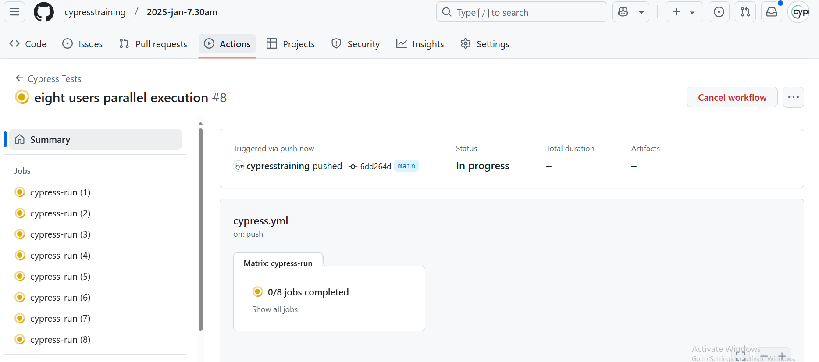

1. Click on 0/8 jobs options to see the details of the each job - e parallel machines we initiated from the cypress.yml

f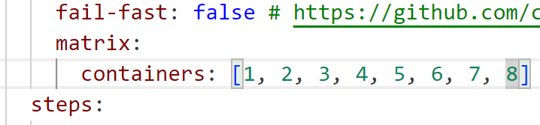

Customize this based on your parallel machines needed for your testing.

1. Select any one job and click on it to expand

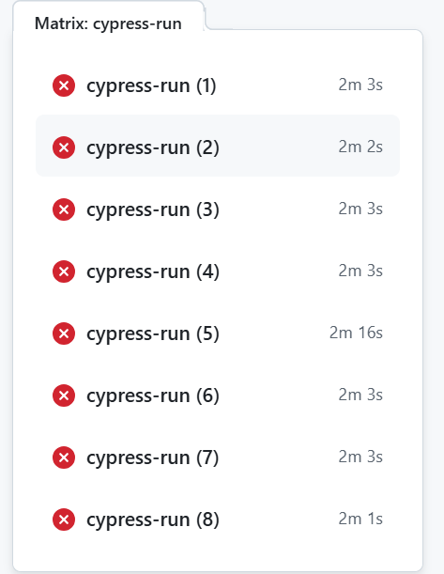

Selected Job 1 to expand and analyse the result –

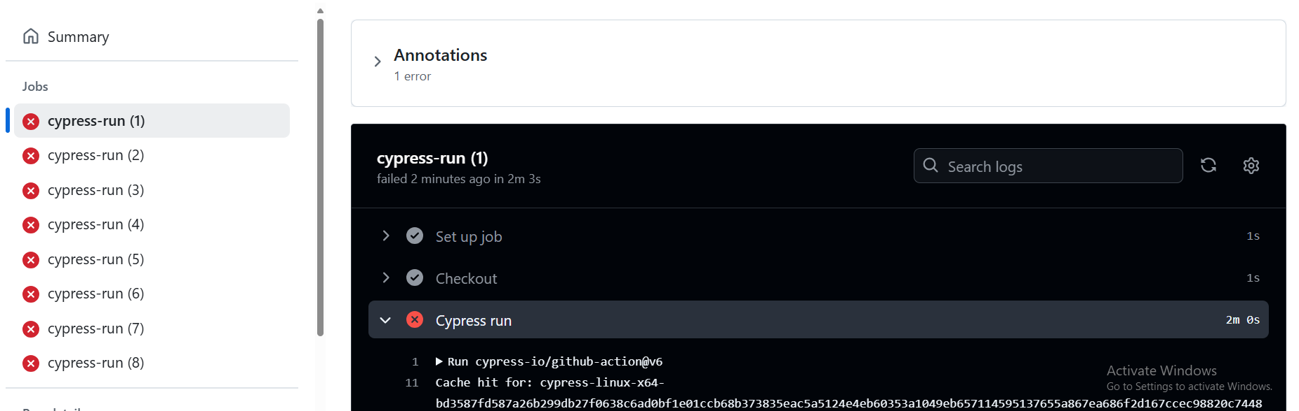expand each section to explore the actions performed .

Setup job : do all the needful setup like installations and other pre requisites available in the selected operating system.

Checkout: get the latest code from git repo

Cypress run - Your npx cypress run will be executed –

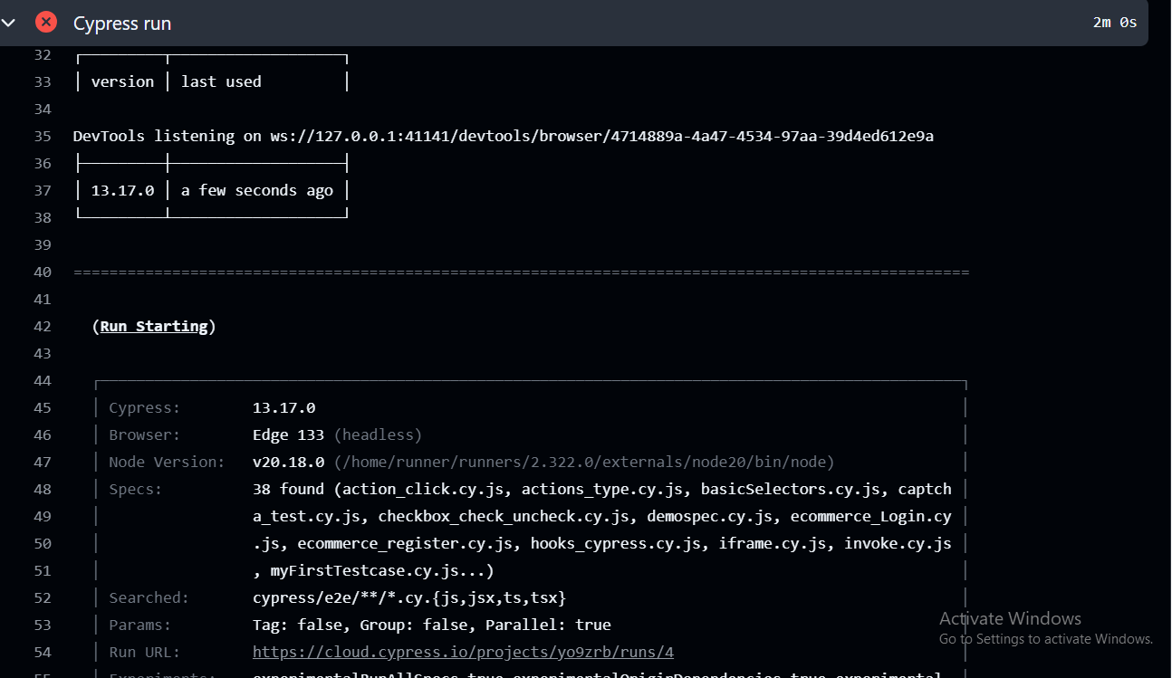

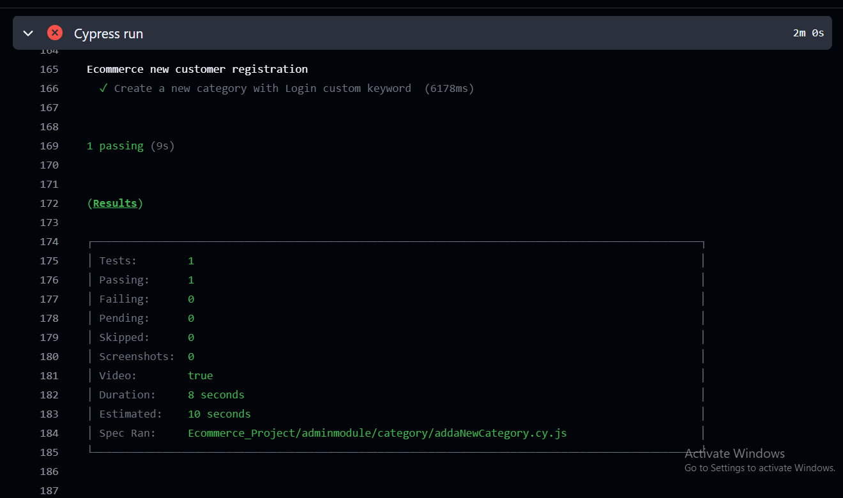

Exactly similar to CLI results .

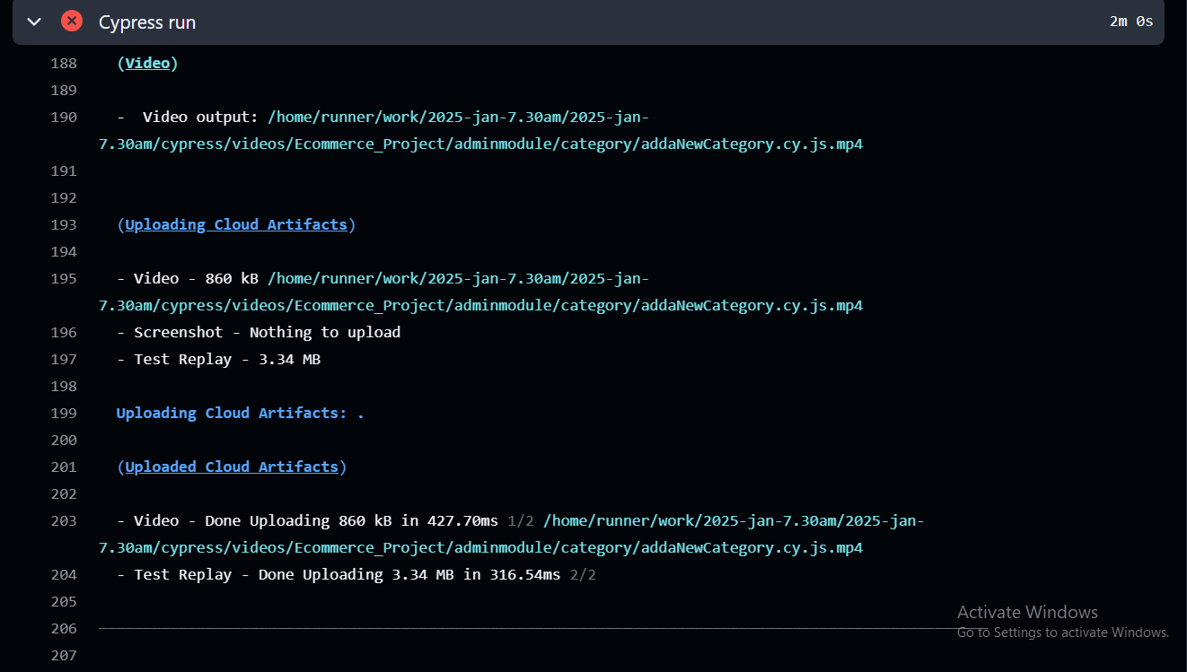

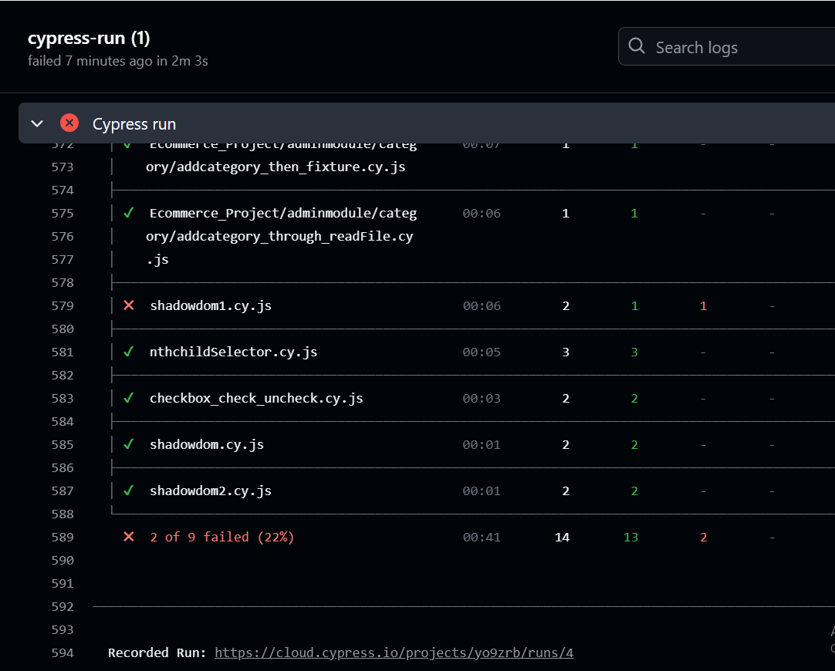

Above run uploaded to cypress cloud and able to see at <https://cloud.cypress.io/projects/yo9zrb/runs/4>

You can login with your cypress cloud details to analyse the results

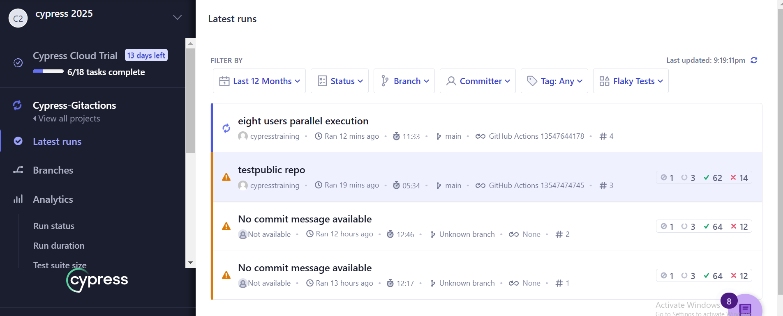

Current run is eight users parallel execution

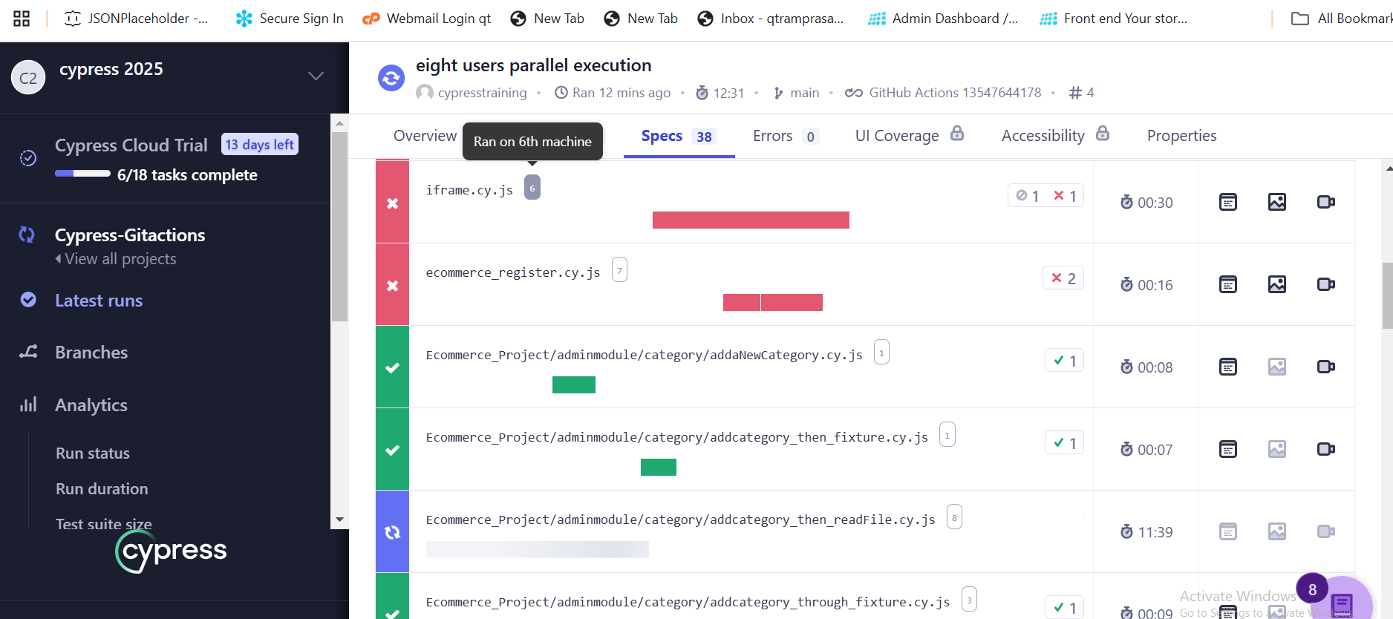

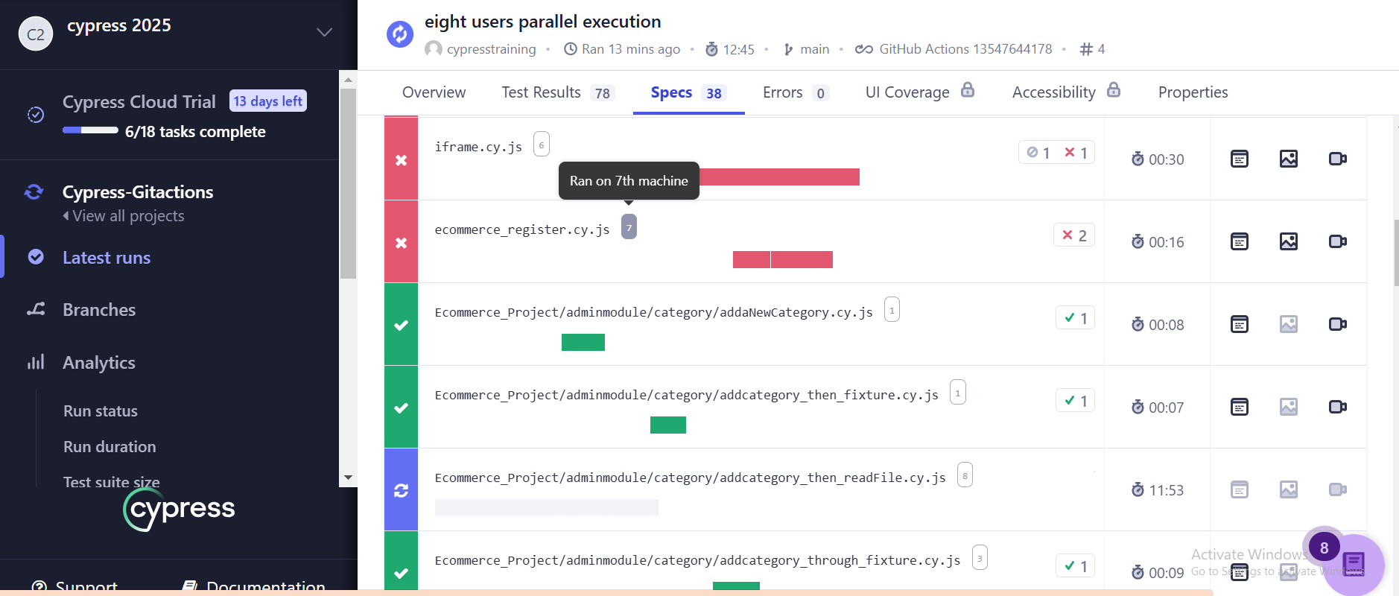

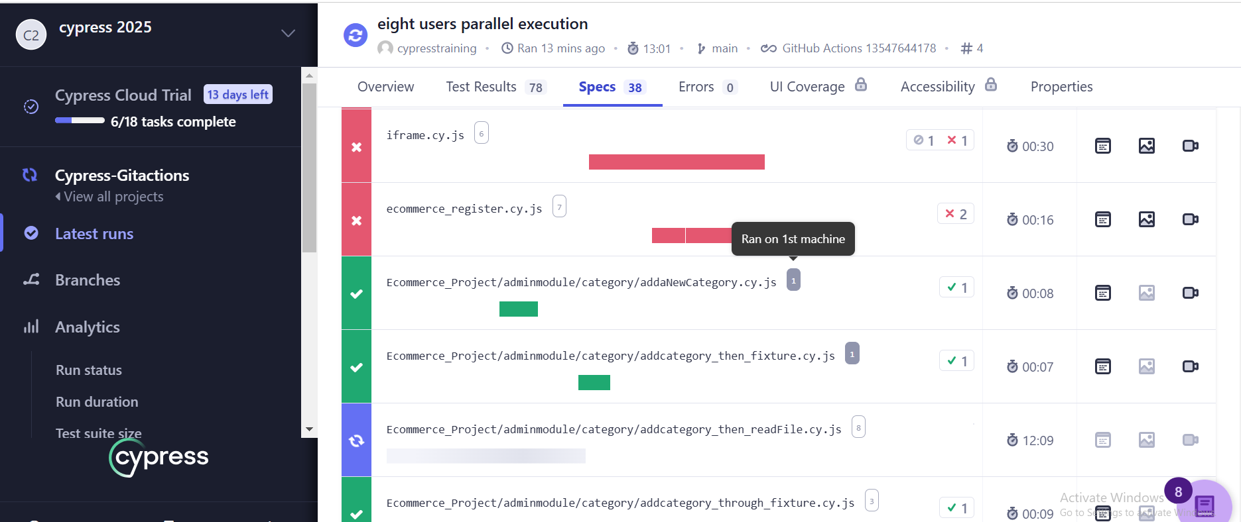

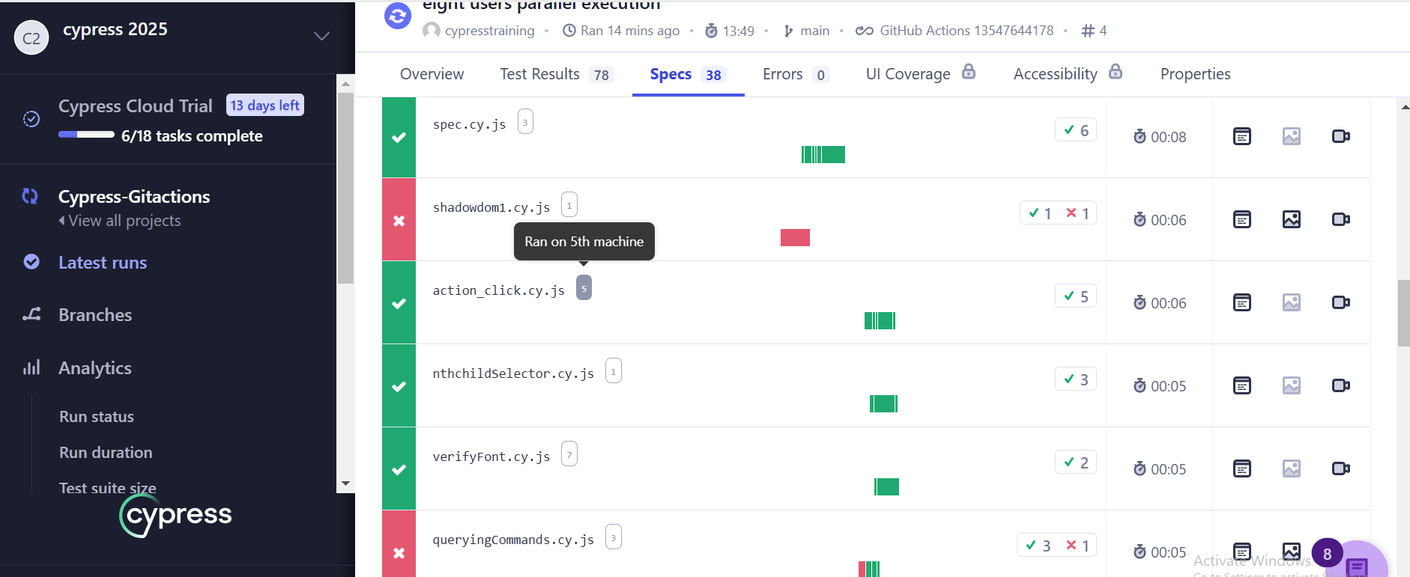

Specs are distributed between 8 machines to execute tests in lesser time

Machine level execution stats:

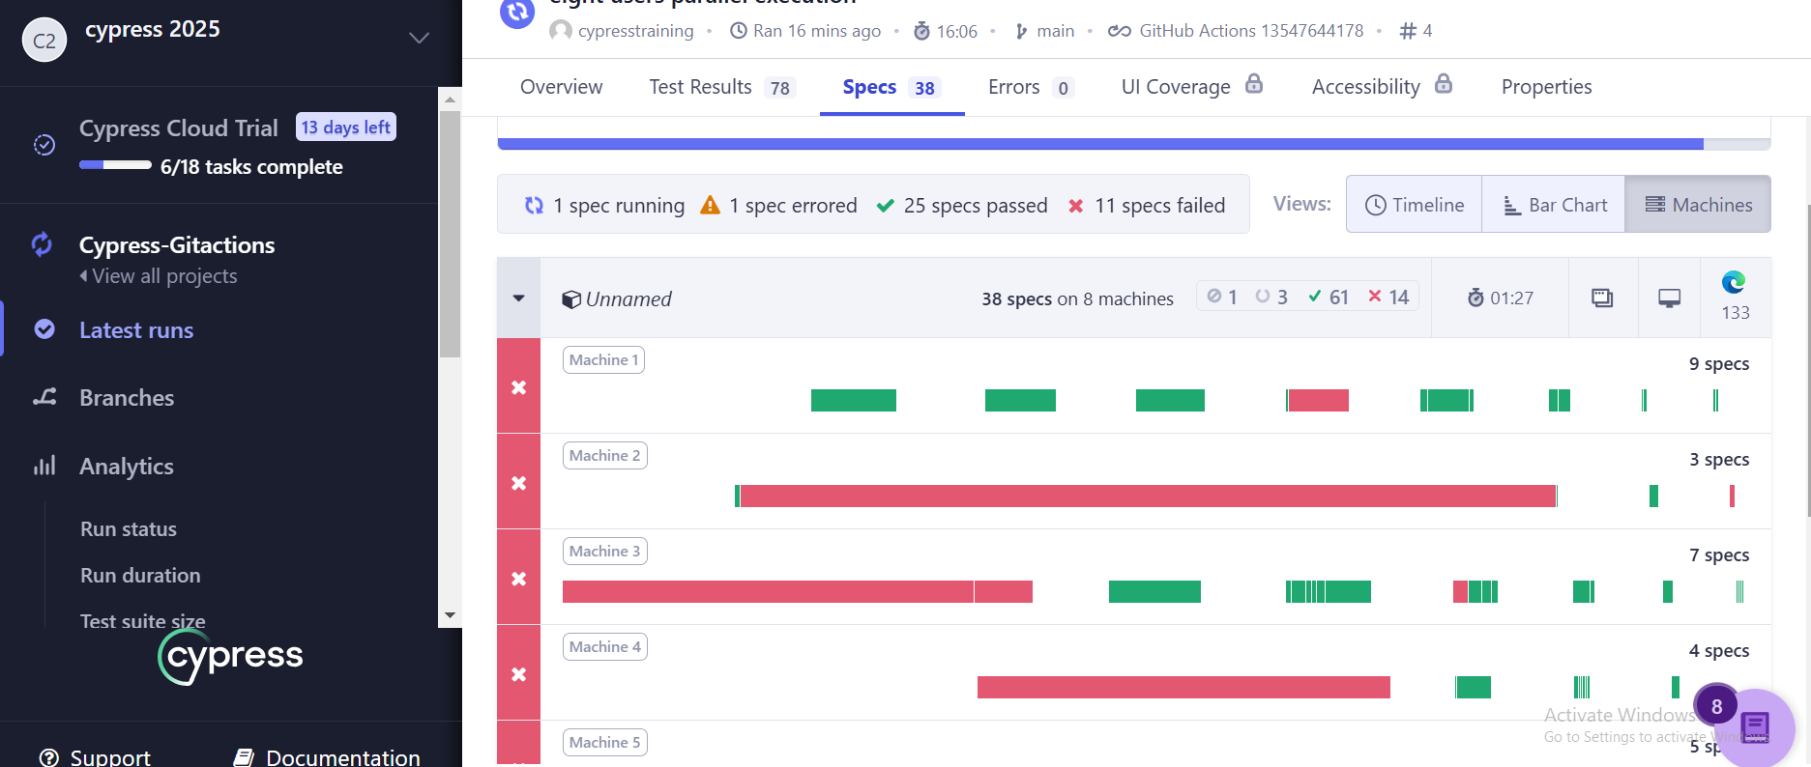

Over all status we can capture through the cypress cloud with minimal efforts.